Task: You must create a form that is similar to the following image: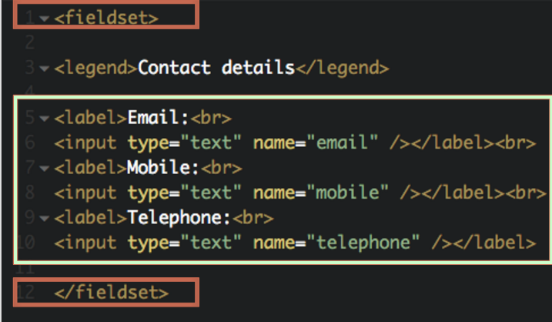

EXTRA CREDIT EVERYONE MUST DO THIS ONE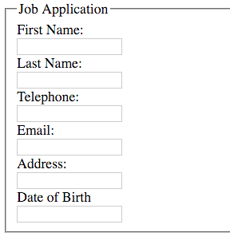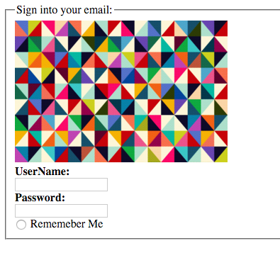

ENTER HTML CODE HERE: